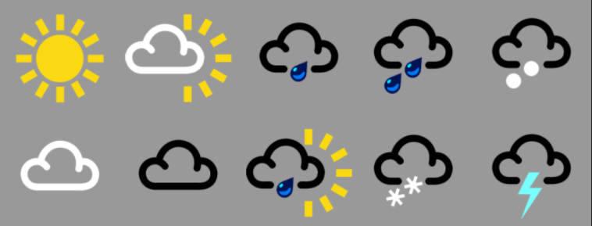
Weather symbols

Can you say which weather each symbol represents?
What kind of weather have we seen this year so far?
What is your favourite weather and why?

