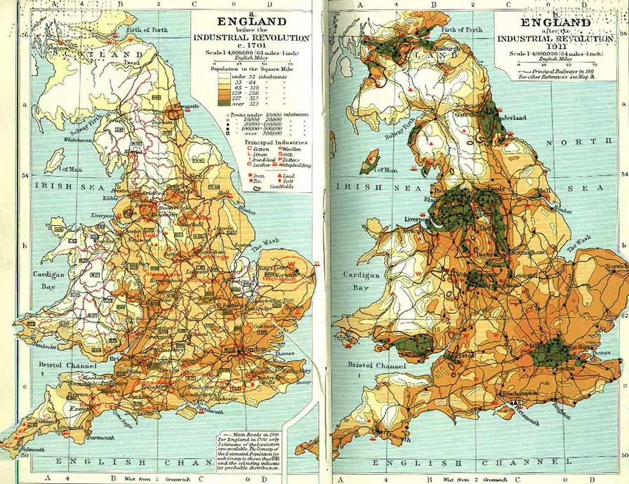

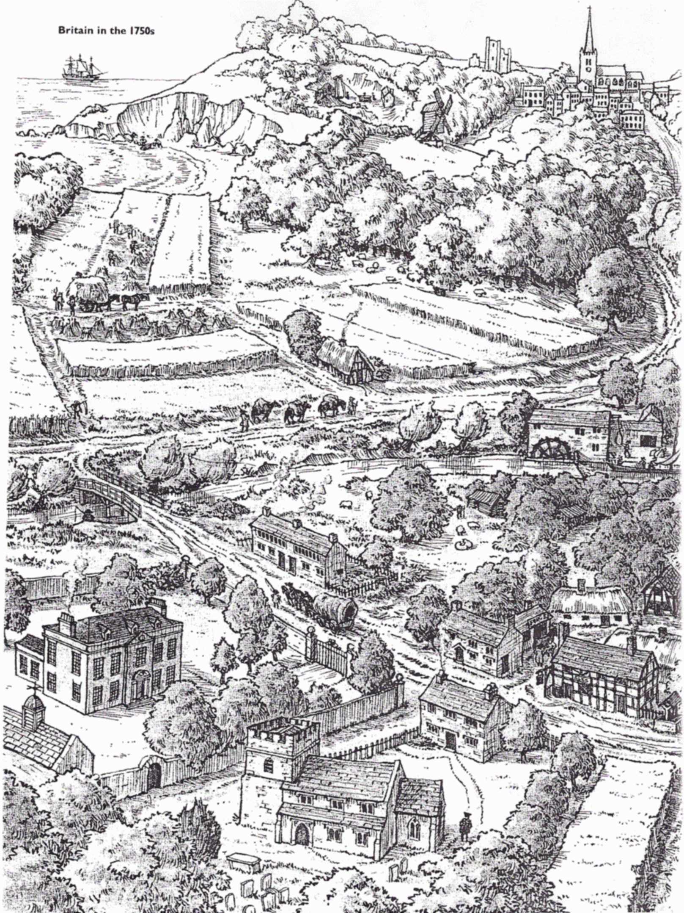

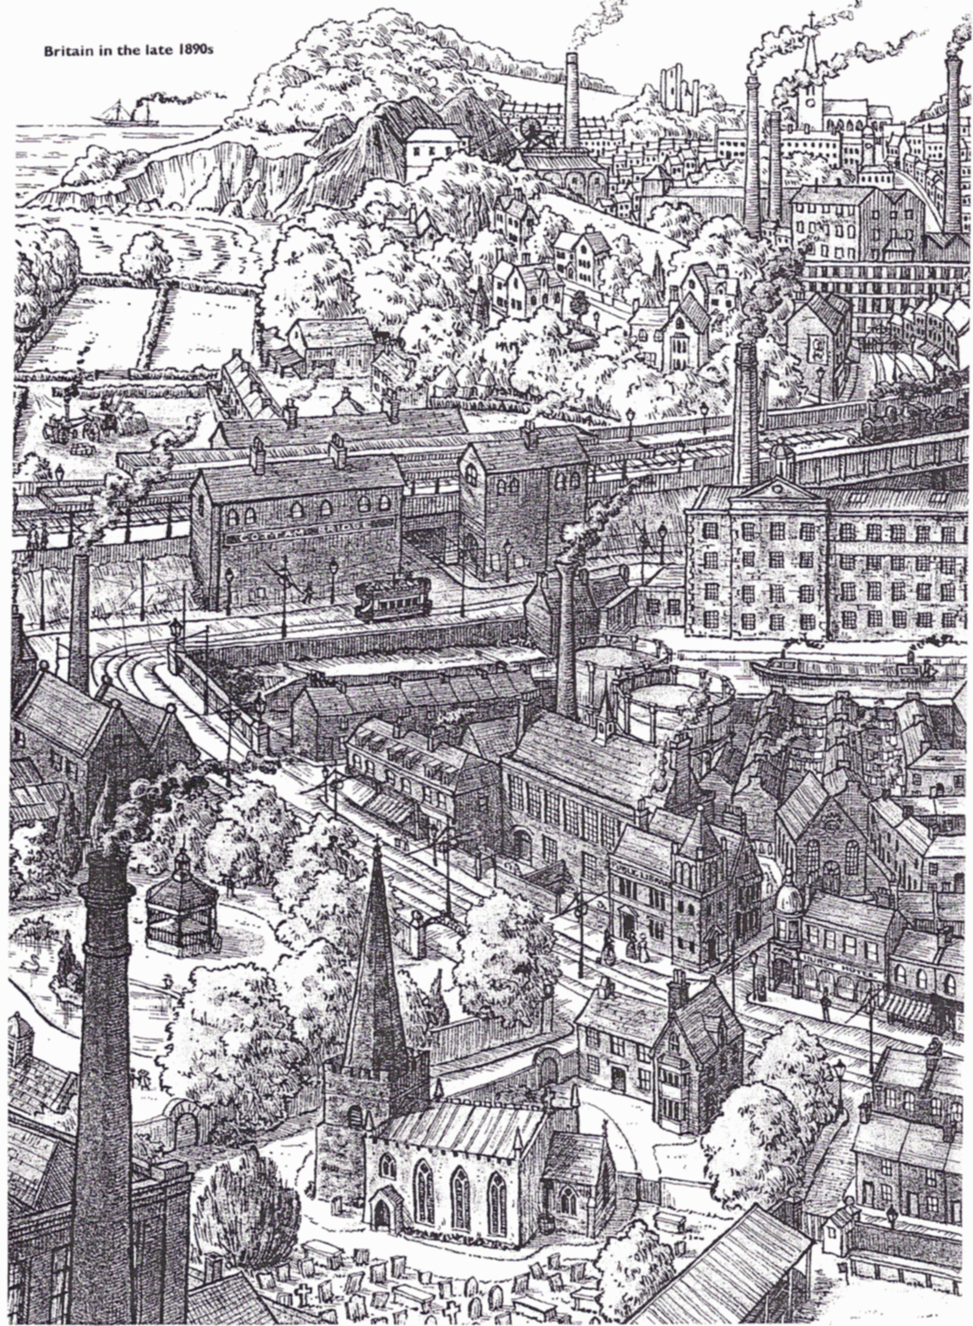

Britain 1750
LAND USE | TRANSPORT | POWER | INDUSTRY

Britain 1890
LAND USE | TRANSPORT | POWER | INDUSTRY

The Industrial Revolution started in the 18th Century (1700’s) and changed Britain forever. But what is the Industrial Revolution?
The Industrial revolution took place more than 200 years ago. In earlier days, people made products by hand. They worked mostly in their own homes or in small workshops. This method then changed to machines manufacturing (making) products.
England was the first country in which these changes took place! However, the Industrial Revolution soon spread to other European countries, the United States, and Japan.
Watch the opening ceremony of the Olympic Games, which took place in London in 2012.
https://www.youtube.com/embed/7QL_uG2GSZo

TASK 1: Look at the Population density map of England before (1701) and after (1911). Why do you think The Industrial Revolution moved people toward each other?

TASK 2: Use the two pictures to complete the tables (Britain 1750/1890). Write about the following things you can see in either picture: Land Use (farms, church, mines etc) Transport (Horse/Cart, Sail boat, Walking etc) Power (wheel water, man power, windmill etc) and Industry (farming, mining, factories etc).

