Spelling / Phonics | ENGLISH Year 3  English | Reading
This week we are going to for a look at the poem The Owl and the Pussy-Cat

Activity 1
Today we are going to be focusing on answering retrieval questions. Now remember the answers to these questions are in the text and you need to skim and scan for key words to find them.

Where was the honey kept?
There are many rhymes in this poem. Write the rhyming pair for each word
boat –
married –
sing –
mince -
Activity 2
Today we are going to giving/explaining the meaning of words in context.

Find and copy a word that means that the boat looked great.
What does the word ‘fowl’ mean in the second verse?

Activity 3
Today we will make inferences from the text/ explain and justify inferences with evidence from the text.

Find a phrase in the first verse that shows how the Owl feels about the Pussy-Cat
Why does the Pussy-Cat need a ring?

Activity 4
Today we will identify/explain how meaning is enhanced through choice of words and phrases

What ideas are we given about the place that the Owl and the Pussy-Cat sailed to?

Activity 5
Today we will identify/explain how information/narrative content is related and contributes to meaning as a whole

Some people think that this poem is about nonsense. Give two reasons why this might be true?

This poem is a happy poem. Explain why using the text to help you.

 |  | Writing
Lesson 1
LO: to understand the meaning of words in the text and find synonyms for them.
Complete the tasks for lesson one

Lesson 2
LO: to be able to discuss vocabulary and answer questions from the text.

Answer the comprehension questions from the booklet

Lesson 3
LO: to use poetry to develop ideas
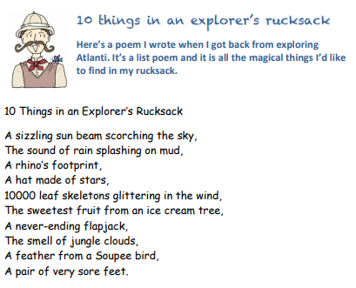

Use the planning sheet provided to create a list poem of all the magical things you would like to find in your explorers rucksack

Lesson 4
LO: to explore grammar in context
Use your plan and add detail to each sentence using the following idea
Task 1
You can add detail to your sentences by using the simple joining words and or but.
For example:
1. I trudged through the dense forest and collected samples of the plant life.
2. I tried to catch a fish but they were too fast for me.
Create sentences about your jungle and add detail using and or but

Task 2
The log uses sentence signposts to tell the reader when something happened in the journey.
The ones used in the log are known technically as ‘fronted adverbials’ – adverbs (or phrases beginning with adverbs) that are placed at the front of sentences to show us WHEN.
These include: First, Next, After that, Then, Afterwards, After a while, Finally, When … ,
For example: 1. Next, I trekked to a clearing and found a beautiful plunge pool.
2. Finally, I headed back to camp because the sun began to set.
Redraft your sentences, using fronted adverbials to show WHEN things happened

Task 3
Now try practising some sentences that will help you explain what you were doing, using because to enable you to explain.
For example: Finally, I headed back to camp because it was getting late.
Take sentences from your ideas above but try adding because to explain why you did something.
Start your sentence with a fronted adverbial again. Remember, you can spin your sentence round and start with because, as well.
For example:
1. First, I set out early because the jungle was far away.
2. Because the jungle was far away, the first thing I did was set out early.
3. After that, I packed my camera because I wanted to photograph the flowers.

Lesson 5
LO: to write a diary entry (jungle log)

Use your plan and the model for Atlanti to write your jungle log.

Remember to:
Add detail to your sentences by using and or but
Add explanation to your sentences using because
Check your capital letters, full stops and commas after a fronted adverbial e.g. after that, first, next,
Don’t forget to read your work and check it flows and makes sense.

