Thursday’s activity

Put the pictures in the correct order as they appear on page 20 of the poem.

Then use Fred Talk to write a sentence for each picture.

Remember the rhyming words.

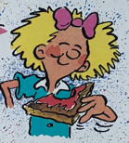 | 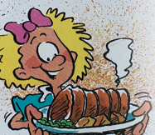
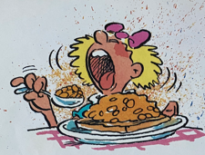 | 