Lesson 6 – To solve addition length problems

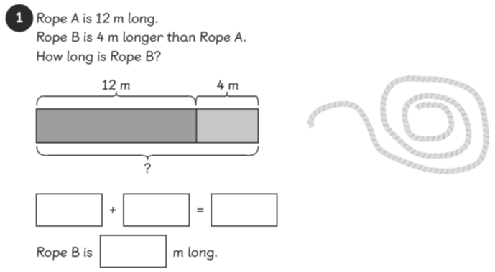
Do 1

Do 2
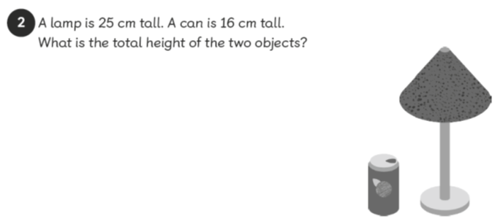

Do 3

Do 4

Do 5

Mum knitted a blanket. On Monday she knitted 23cm and on Tuesday she knitted another 37cm to finish the blanket.
How long is the finished blanket?
Do 6

The upstairs corridor at school is 35m long and the downstairs corridor is 24m longer.
How long is the downstairs corridor?
Do 7
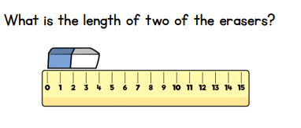

Think
Convince me
Convince me that if my plant is 7cm and grows another 9cm it will be 16cm tall.

Explain
