**Lesson 4 – Reading data counting in 5’s**

**Do 1**

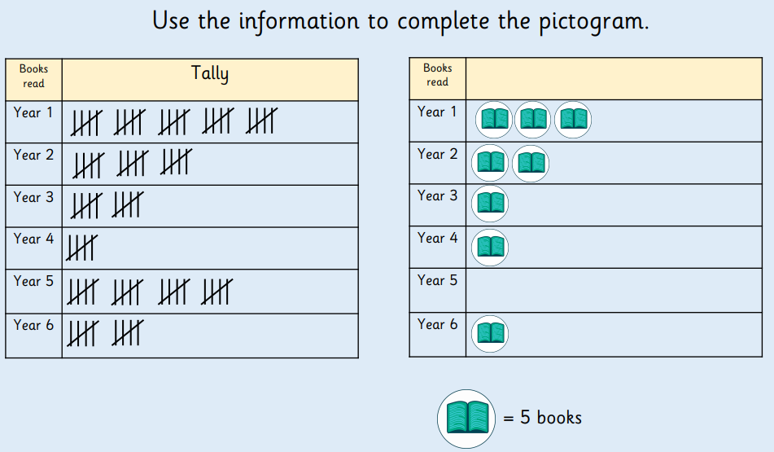

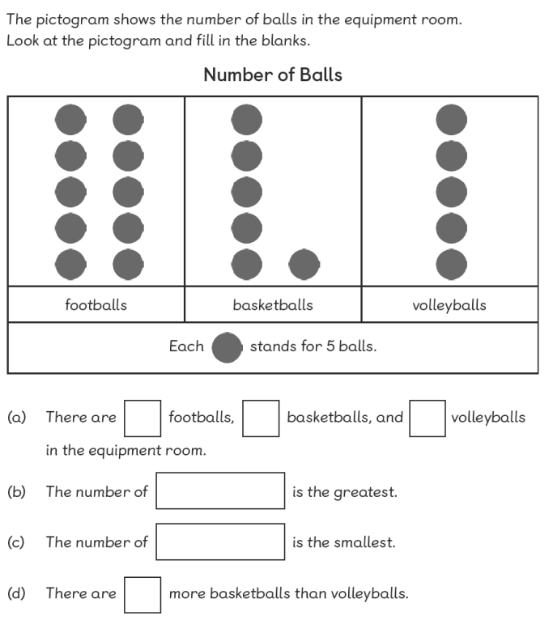

**Do 2**

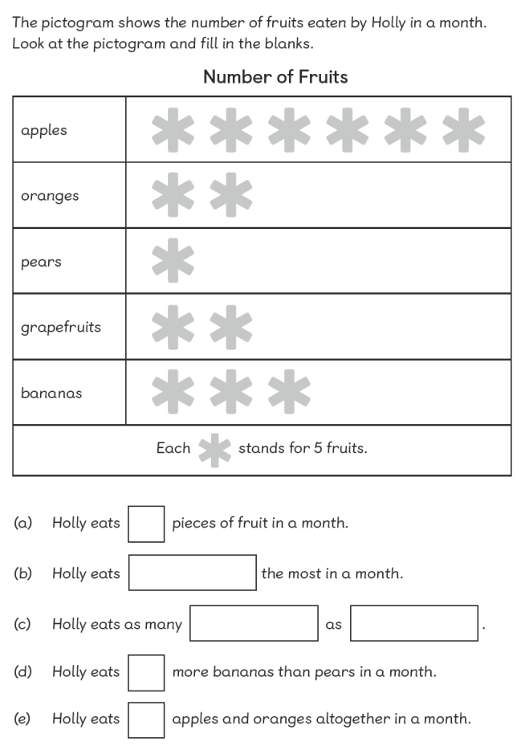

**Do 3**

**Do 4**

**Complete the pictogram**

|  |  |
| --- | --- |
| **Diamond** | **30** |
| **Emerald** | **25** |
| **Ruby** | **15** |
| **Sapphire** | **40** |

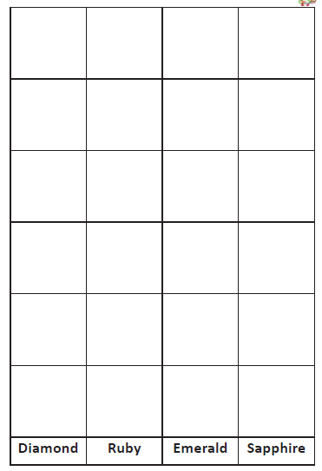



**= 5**

**Think**

**Prove it**

Prove this pictogram is completed correctly.

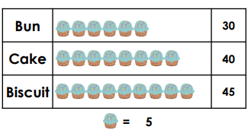

**Explain**

