Spelling and Grammar | English Plan Year 6 1/02/21 | Reading Information texts, ‘The Humble Potato’ and ‘The Earthship’.
Spelling  Read Write Inc. Spelling: Unit 10: words ending -ible and -able.  Special focus: hyphens.  Grammar Key Skills  Revise different types of sentences and use them effectively in own writing. |  | Activity 1  Read the text, ‘The Humble Potato’. Read it through more than once and keep referring to it when you answer the questions below.  Questions about the text  Where were potato plants first grown for food? (1 mark)  Which of these were the Spanish traders looking for? Tick one. Potatoes, food, gold or farms? (1 mark)  Look at the section headed: Where it all began. Find and copy one phrase which shows that some people in Europe were unsure about eating potatoes. (1 mark)  Activity 2  Re-read the text, ‘The Humble Potato’.  Questions about the text  Look at the section headed: How the potato arrived in Britain. Identify one piece of information which shows that potatoes were an exciting discovery. (1 mark)  Legend has it that the cooks threw away the potatoes … Draw a line (or tick) to show the phrase that is closest in meaning to Legend has it. It is certain that. It is believed that. It is hoped that. It is not that. (1 mark)  Look at page 2. Explain why the potato crop is important to people today, all over the world. Give two reasons. (2 marks)  Activity 3  Read the text, ‘The Earthship’. Keep referring to the text when you answer the questions.  Questions about the text  How many tyres have to be thrown away every year? (1 mark)  Complete the table to show how the Earthship provides the following. One has been done for you. (2 marks)  Activity 4  Re-read the text, ‘The Earthship’.  Questions about the text  ...maintains a comfortable living temperature... Give the meaning of the word maintains in this sentence. (1 mark)  ‘Earthship’ is made up of two words: earth and ship. Why are these two words used for this new type of house? (2 marks)  How does the text prove that Earthships cost very little to run? (2 marks)  Activity 5  Re-read the text, ‘The Earthship’.  Questions about the text  This leaflet gives information about the Earthship. How does it also advertise the Earthship? Find two points. (2 marks)  Quotations are included from people who like the Earthship. Write your own comment about the Earthship to include in the leaflet. (2 marks)
 |  | Writing Information texts: Earthlings (research different text types and gather ideas to write own hybrid information text)
Activity 1

Key Skills Revise different sentences.

Sentences can have different purposes:
- statements – sentences which state facts, e.g. It is very cold.
- questions – sentences which ask for an answer, e.g. Are you cold?
- commands – sentences which give orders or requests, e.g. Do not play in the snow.
- exclamations – sentences which express a strong feeling or emotion, e.g. What a freezing day!

Task

Make up your own examples of each sentence type. Now complete the task below.

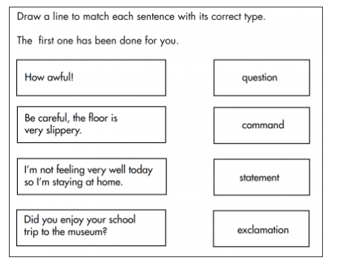
LO: Identify the language and layout features of non-fiction text types.
Today we are starting a two-week unit on information texts with our outcome piece being a hybrid information text about Earthlings. We will be basing this on the Dr Xargle books that you may have read when you were younger.
Have a think about all the different non-fiction text types you can think of. There are six types: recount, report, persuasion, explanation, instructions and discussion. Sometimes we come across texts that have elements from more that one genre. We call these texts hybrid texts. Think of a hybrid car or a hybrid flower.

Activity: cut up the non-fiction matching cards and sort them so that each text type has a summary of the structure and language features and an example of the text type. There should be three cards in each group. Find a text online. Does it fit better into one category? Does it have features from more than one text type? Is it a hybrid text?

Activity 2
Key Skills Revise compound sentences.
Simple sentences only have one subject and one verb (despite any added description). If we wrote with simple sentences all the time our writing would be dull. A compound sentence is made up of two or more simple sentences joined by a conjunction. Here are two simple sentences: The ship hit the rocks. It sank to the bottom of the sea. They can be made into a compound sentence: The ship hit the rocks and it sank to the bottom of the sea. The conjunction, and, is used to join the two simple sentences. The best conjunctions for compound sentences are the 7 that we remember when we say FANBOYS. Can you remember them? (For, And, Nor, But , Or, Yet, So)

Join the following sentences together to make compound sentences. Choose the most suitable conjunction from the list above.

Task
1. I enjoy reading. I don’t enjoy cooking.
2. Ben is thoughtful. He always plays with me when I’m lonely.
3. Kate walked home from school slowly. She was tired.
4. Babies cry all of the time. They can get some attention from their mum.
5. I can use simple sentences in my writing. I can use compound ones to make it more interesting.

LO: Generate and answer questions about a non-fiction text.
Read Dr Xargle’s Book of Earthlets. This is a parody of a non-chronological report. What do you think the word ‘parody’ means? Can you spot any features that we came across when we wrote our non-chronological reports on animals recently?
Activity: imagine you are an alien pupil. What have you learned about Earthlings (and Earthlets in particular) from the information text? Bullet point the key information. Write two questions that you would like to explore further about Earthlets.

Activity 3
Key Skills Revise phrases.
A phrase is a group of words that does not make complete sense on its own and does not contain a verb. E.g. up the mountain. This does not make complete sense. The climber struggled up the mountain. This makes sense now.
We know about adverbial and noun phrases, don’t we?

Task
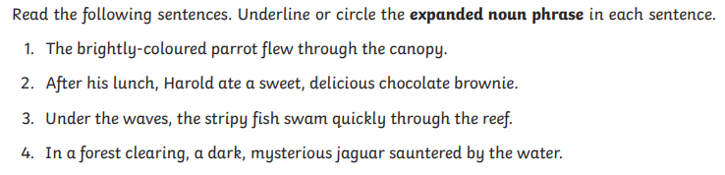

LO: Identify the features of an information text and use as a model for our own ideas.
Do you remember the different text type matching cards we looked at on Monday? If we were writing about a topic like food or eating, we would be able to use any of the text types to produce different types of writing. For example:
Instructions – How to make a healthy fruit salad; Discussion – Should all children be given free healthy snacks at school? Recount – Sir Walter Raleigh and the discovery of the potato; Explanation – The life cycle of an apple; Report – The Marcus Rashford effect on free school meals; Persuasion – Why you should eat more than five portions of fruit and vegetables a day. You could do this for any type of writing.
Activity: continue this game by thinking of six different text types for cats. Can you come up with the titles for the six different text types? Use the matching cards from Monday’s lesson to help you.
Read the text, Dr Xargle’s Book of Earth Hounds. What are Earth Hounds? What have we learned about them from this text?
Activity: create a dictionary for the different ‘alien’ words and phrases. For example, hound = dog; fangs = teeth; waggler = tail.
then create some sentences to describe an Earth Tigger in the same style as this text. We will read the actual text tomorrow.

Activity 4
Key Skills Revise complex sentences.
Watch the Loom video to see how we can improve our descriptive writing with complex sentences.

Look at this example of a simple sentence: The girl walked into the classroom. It can be transformed into a complex sentence so that it gives more detail to the reader. As the girl, with flaming red hair and freckles on her nose, walked into the classroom, all heads turned to stare at her.

Task
Expand these sentences with more detail and a subordinating conjunction to make them into complex sentences.
- The house was in front of her.
- Jake skipped down the road.
- The cat sat on the mat.
- There was a large field.

LO: Construct different sentences suitable for an information text.
Firstly, how did you get on yesterday? Did you come up with some great sentences for an information text on Earth Tiggers? Let’s read that text now and see how it compares to your ideas.

The texts we have read this week are amusing parodies of information texts but do they have enough of the formal language that we would expect to see in an information text? Let’s have a look at a few examples that do work: They come in four colours.
To stop them leaking, Earthlets must be pulled up by the back tentacles and folded in half.
For many days, they drink only milk …
For dinner they consume …
Activity: write some formal sentence openers with fronted adverbials for a text on Earth Tiggers.

Activity 5
Key Skills Revise different sentence starters.
Do you remember how we have been trying to use a range of sentence starters in our writing?
Task
Create sentences using an -ed, -ing and a prepositional starter. E.g. Designed to be waterproof, Earthlings do not leak or let water in.
Smiling and crying are two of the ways that Earthlings show how they feel.
On top of their heads, Earthlets grow fur but not enough to keep warm.

LO: Identify the different features of a hybrid text.
This week we have been gathering ideas for next week’s written outcome piece. Here is an example of a hybrid text called ‘The Way of the Dodo’. Read it twice.
Activity: read the hybrid text, ‘The Way of the Dodo’. What features does it have? Can you spot explanation, persuasion and report features? Does it use the features of any other text types? Highlight and annotate the text, identifying the different language and layout features.

