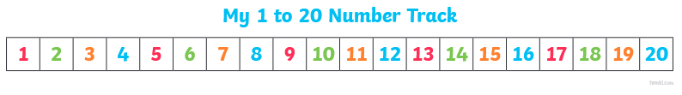
26.01.21
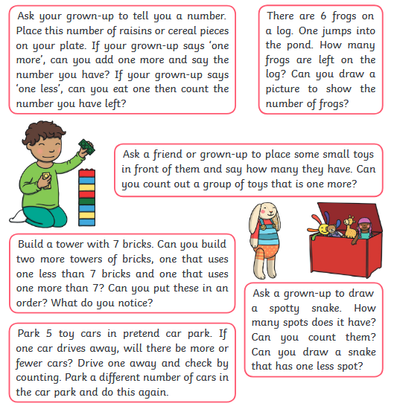
Activities to support one more and one less.
Don’t forget to e-mail some pictures to us of you completing the activities. We’d love to see them!
receptionhomework@sandylands.lancs.sch.uk

