Medusa’s face is as green as pond weed and a slimy as a snail.
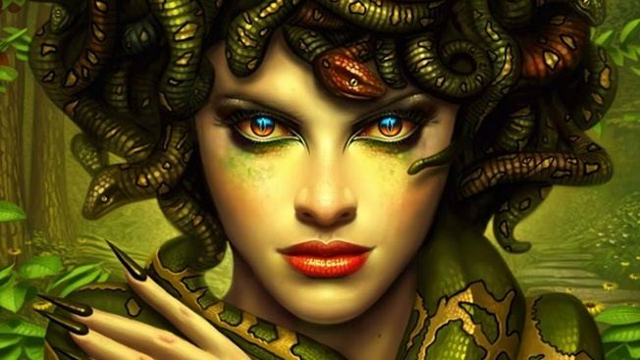
Furthermore, the rough bumps on her face make you want to look at her ugliness. Terrifyingly, her poisonous, red eyes have that much power that just a single glance will turn you into solid stone. In addition, her eyes barely blink. In fact if you look into something shiny, something as shiny as a gold shield, you will see they only blink every twenty seconds.
Meanwhile, her lips glow, blood red, and sparkle because she’s been
licking her lips just waiting for someone to come…
However, her cackling witch like laugh really scares people.
You will find near enough every time that she turns somebody
to stone she will laugh afterwards.

Medusa’s face is as green as pond weed and a slimy as a snail.
Furthermore, the rough bumps on her face make you want to look at her ugliness. Terrifyingly, her poisonous, red eyes have that much power that just a single glance will turn you into solid stone. In addition, her eyes barely blink. In fact if you look into something shiny, something as shiny as a gold shield, you will see they only blink every twenty seconds.
Meanwhile, her lips glow, blood red, and sparkle because she’s been
licking her lips just waiting for someone to come…
However, her cackling witch like laugh really scares people.
You will find near enough every time that she turns somebody
to stone she will laugh afterwards.
She was ugly with bumps on her face.

Her red eyes were evil and turned you into stone.
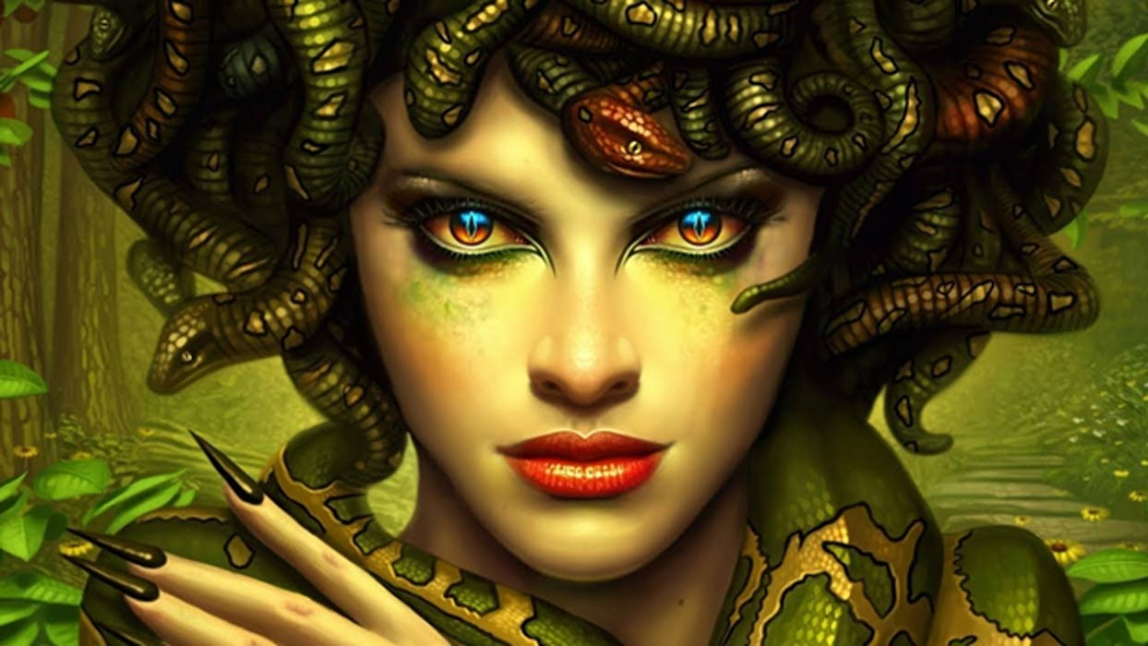
Medusa never blinked.

She always licks her red lips.

Her laugh scares people.

She laughs when she has turned somebody to stone.

