MATHS Year 6 WB 6.7. 20
I can calculate opposite angles
I can calculate angles in triangles
I can calculate angles in quadrilaterals
I can calculate angles in polygons
Lesson 1
In this lesson, we will be looking at opposite angles
SHOW – Watch your home learning video for today’s lesson
https://whiterosemaths.com/homelearning/year-6/
WB 6.7.20 Lesson 1
DO – Activity sheet Lesson 1 Activity sheet answers
Maths No Problem Text Book B page 120-125
Lesson 2
In this lesson, we are going to be looking at angles in triangles
SHOW – Watch your home learning video for today’s lesson
https://whiterosemaths.com/homelearning/year-6/
WB 6.7.20 Lesson 2
DO – Activity sheet Lesson 2 Activity sheet answers
Maths No Problem Text Book B page 126-128
Lesson 3
In this lesson, you will be learning how to calculate angles in quadrilaterals
SHOW – Watch your home learning video for today’s lesson
https://whiterosemaths.com/homelearning/year-6/
WB 6.7.20 Lesson 3
DO – Activity sheet Lesson 3 Activity sheet answers
Maths No Problem Text Book B page 129-30
Lesson 4
This lesson will be about angles in polygons
SHOW – Watch your home learning video for today’s lesson
https://whiterosemaths.com/homelearning/year-6/
WB 6.7.20 Lesson 4
DO – Activity sheet Lesson 4 Activity sheet answers
Maths No Problem Text Book B page 131 - 133
THINK EXPLAIN SOLVE
Here are some great challenge questions for our school maths model
Activity Sheet
Additional tasks and resources
TT Rockstars – continue with your daily access to TT Rockstars.
The highest scoring class will go on facebook each week so come on year 5!
Numbots – maths games and activities
Game of the week:
https://www.mathplayground.com/alienangles.html
Alien angles
http://www.primaryhomeworkhelp.co.uk/maths/shapes/angles.html
on this website there are a few games on angles.

Information page year 6
Lesson 1 – Opposite angles
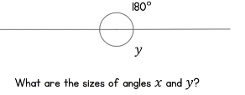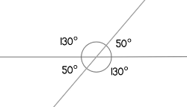
Vertically opposite angles are equal a long a straight line.
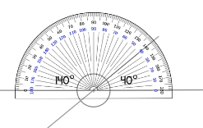
Lesson 2 – angles in triangles

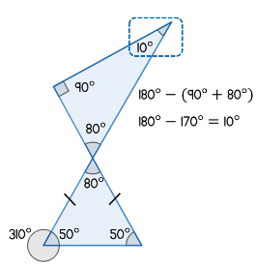
Remember
Angles in a triangle add up to 180 degrees.
Vertical opposite angles are the same

Lesson 3 angles in quadrilaterals
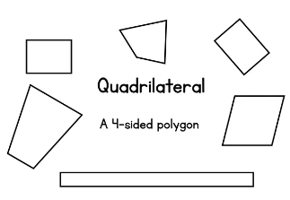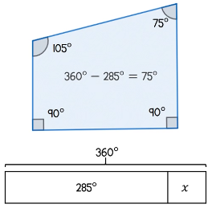
Angles in quadrilaterals all add up to 360 degrees.

Lesson 4 – angles in polygons
