Task: cut out the images or list them in a table and organise them into Arctic and Alpine Tundras.
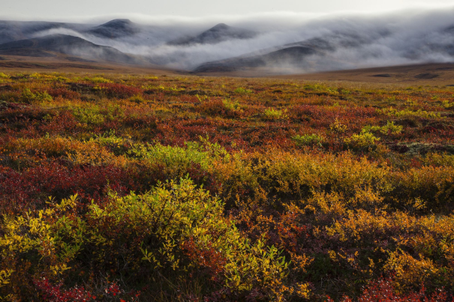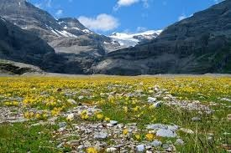
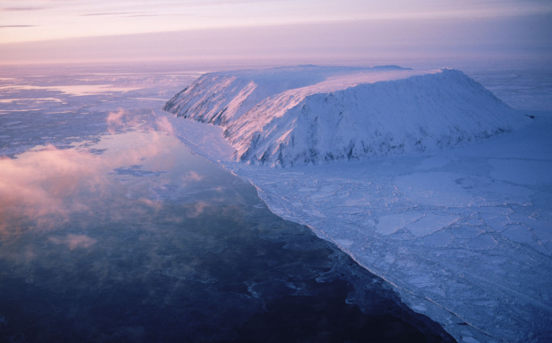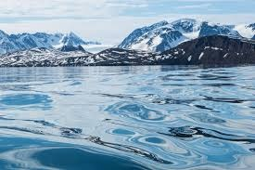
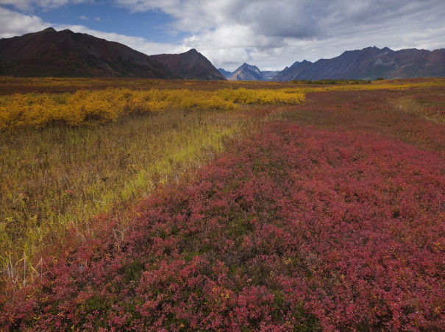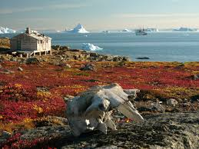
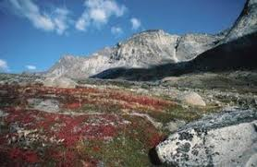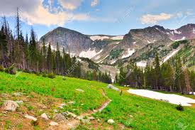

Climate change
A warmer climate could radically change tundra landscapes and what species are able to live in them. Warming could destabilise the tundra’s ecosystem The release of methane from deteriorating permafrost, for example, feeds the thawing cycle, while higher temperatures drive the growth of shrubs, which can change soil temperature and prevent snow from reflecting out heat.
Thriving shrubs also crowd out lichen, an important food source for caribou and other animals. Warmer tundras could also see increased risk of wildfires and drought.

Watch the video on climate changes
https://www.nationalgeographic.com/environment/habitats/tundra-biome/
https://www.exploratorium.edu/video/tundra-climate-change

Task:
- List the main causes and effects and fill in the table
Cause | Effect

