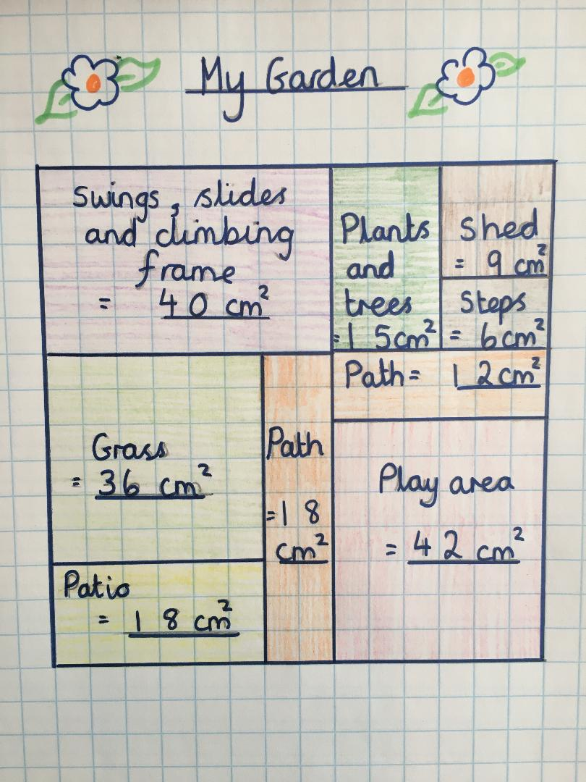
- What is the largest area?
- What is the smallest areas?
- What is the total area of the patio?
- True or false the Grass is smaller than the Play area?
- Challenge! What is the total area of my garden?
Now create your own garden design. Draw rectangles to show the key areas and make sure you label each rectangle with the areas.

