Geography - Biomes  This week we will be looking at biomes. Biomes are areas of our planet with similar climates, landscapes, animals and plants. What lives in a biome depends on how warm or cold it is, how dry or wet it is and how fertile the soil is?  We will be learning about different types of biomes. Look at the world map on the class page. Can you see where in the world you can find these biomes? Why do you think these biomes are located where they are?  Imagine you are going on a trip to a rainforest. What would you need to pack to survive? Think about the climate and weather. | P4C - Do we need rainforests?  Deforestation is the act of clearing away many trees by cutting or burning. It is usually done in order to make way for growing crops or farming cattle, for building roads and towns, or making use of the woods. Trees are useful and valuable. Some people are against deforestation, they say it damages many habitats. Others think it is OK because the trees provide humans with fuel, paper and land for farming. Look at the for and against sheets. And discus the question at the top of the box. | Science  The animals in a biome depend upon plants and food. The plants in a biome also depends on the animals for spreading pollen and seeds so that new plants can grow. So, both plants and animals rely on each other to stay alive.  Select one of the rainforests to research all the living things. What plants grow there and why? What animals live there and why? Think about the climate and nutrients in the rainforests.  Create a non-chronological report such as a tourist leaflet to explain what you have found. Remember to use subheadings such as climate, animals, plants and a did you know?
Eden North Project Week 2
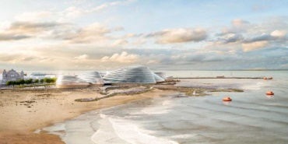

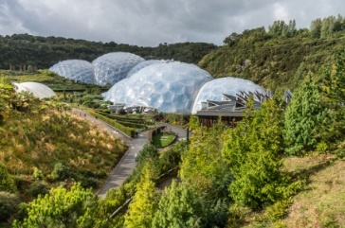

Biomes June 2020
Eden & Eden North
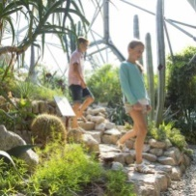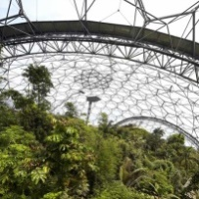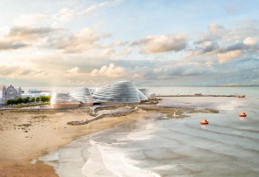
Have a look at the Eden Project Cornwall & Eden North fact sheets and websites to find out more about the Eden complexes
https://www.edenproject.com/
https://www.edenproject.com/eden-story/our-ethos/eden-project-north
The Eden Project (Cornish: Edenva) is a popular visitor attraction in Cornwall, England, UK. Inside there are two biomes which have plants that are collected from many diverse climates and environments. The complex is dominated by two huge adjoining domes that house thousands of plant species. The largest of the two biomes simulates a rainforest environment (and is the largest indoor rainforest in the world) and the second, is a Mediterranean environment. The attraction also has an outside botanical garden which is home to many plants and wildlife native to Cornwall and the UK in general.
The Eden Project North in Morecambe, Lancashire, with a focus on the marine environment.
Geography – Rainforests  Tropical forests are some of the richest, most exciting areas on earth. They are home to gigantic trees, colourful birds and a huge variety of fascinating mammals.  Can you find and locate the rainforests on the blank map of the world? What do you notice about their locations?  Look through the ‘Where are tropical rainforests?’ PowerPoint and discuss why the rainforests are located where they are. Think about climate and weather. |  | Art  Henri Rousseau is a French artist who is known for painting jungle scenes such as a Tiger in a Tropical Storm. (see the attached sheet). He is known as a post-impressionist. This was an abstract style of art, which means that he didn't try to paint things exactly as they look in real life.  Take a look at the examples of Henri’s artwork on the PowerPoint and create your own painting or picture in the style of Henri Rousseau.

