Phonics -  Read the Story A Dog on a Log (Click the link)  Can you find the rhyming words? Clap your hands when you hear one!  Can you find all the words with ee in and write them down?  Can you write a list of items you would take to the beach? | Maths -  Can you count in 2s?  Practise with these songs https://www.youtube.com/watch?v=GvTcpfSnOMQ  https://www.youtube.com/watch?v=OCxvNtrcDIs  Can you make your own 2s number line from 0-20 to help you remember?  Or you could print out this resource to help you!  https://www.twinkl.co.uk/resource/t-t-12226-counting-in-2s-dot-to-dot-sheets-animals | Beauty Surrounds – Art  Have a look at the birds on the sheet. Can you draw any of them?  Which colours will you use?  Could you make a 3D Eden North using recycling?  There’s a picture on the sheet.
Nature Astounds - Science  Take a trip to the beach.  Can you spot any of the seaside birds from the sheet? Put a tick next to any that you see? Describe what the birds look like to your grown up - what colour are they? What size are they? What do you notice them doing?  Think about and discuss how these birds are suited to living at the seaside. For example, long beak to dig in the sand, ability to dive down for fish. | Eden North Project – June 2020  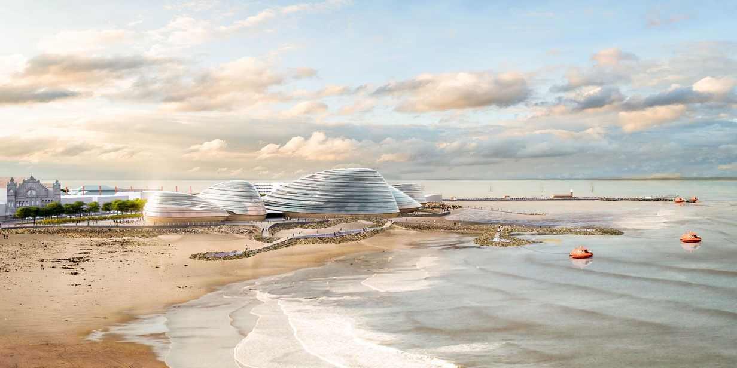  Beauty Surrounds, Health Abounds and Nature Astounds | Beauty Surrounds – Music  Can you memorise this tongue twister?  “She sells sea shells on the sea shore”.  How quickly can you say it without making any mistakes?  Can you learn the song ‘oh I do like to be beside the seaside”?  https://www.youtube.com/watch?v=A8puscX7tVU  Can you teach someone else the song too?
Nature Astounds – Knowledge and Understanding  Have a look at the birds on the sheet. Can you find anything out about them? |  | Health Abounds – Physical Development  Have a go at cosmic yoga- under the sea.  https://www.youtube.com/watch?v=qC83oFEeVZA  How many different creatures can you see?

