Beauty Surrounds – Geography  Morecambe Bay is the largest estuary in the North West of England. You might not have noticed but it is home to several islands.  Can you research these islands to find more information about them? What are they called? How big are they? How can people access them? What plants and animals can be found there? How have they been created?  You can display your findings in any way you would like. For example, a poster, fact file or brochure. | Beauty Surrounds – History  Morecambe used to have a thriving tourism industry. Research the history of Morecambe’s tourism. Why did people visit Morecambe? Where did they come from? How has it changed?  Create a poster showing how tourism in Morecambe has changed.  Things to research  the pier, illuminations, Bubbles, Happy Mount Park, Frontierland, The Winter Gardens, beaches,  www.youtube.com/watch?v=jEaj-ZvEbMw  www.youtube.com/watch?v=KLRQ8ElrEoU | Beauty Surrounds – Art  On a clear day Morecambe has the most spectacular views across the bay to the Lake District. According to their plans, Eden North will be facing that view. Plan and create a Mural of the bay that could be displayed across one of the walls in Eden North visitor centre.  Chas Jacobs is a local artist who uses bright bold acrylic paints. Look at the attached sheet for examples of his artwork as well as examples of murals. Use these as inspiration for your work.  https://www.chasjacobs.co.uk/
Nature Astounds – Science  The Eden project aims to educate people about living things and their habitats. Morecambe Bay is home to many plants and animals.  Can you find out which living things live in Morecambe and why? How might the Eden project educate people about them?  You could create a fact file or draw and label the living things you have found.  www.youtube.com/watch?v=GSt9MWhe_HE | Eden North Project – June 2020  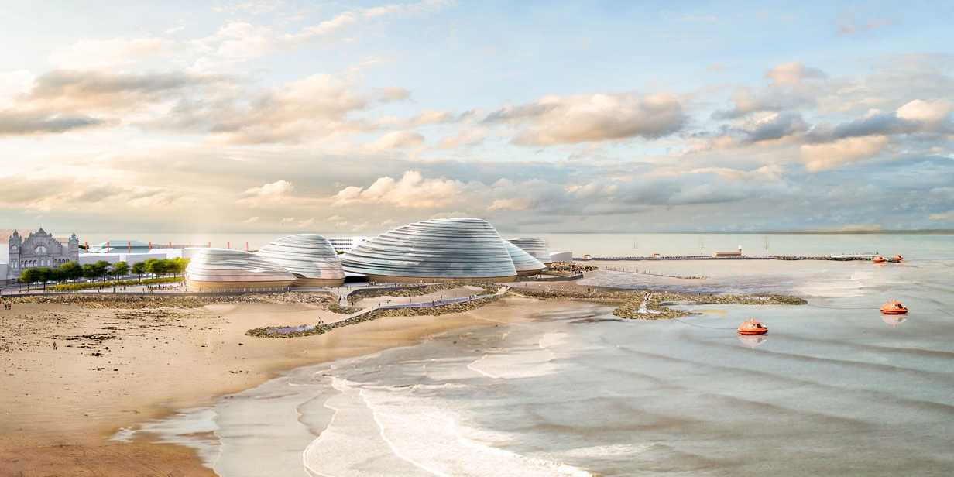  Beauty Surrounds, Health Abounds and Nature Astounds | Health Abounds – PE / Well-being  Morecambe is a wonderful place to keep fit and healthy. Create a list of the different forms of physical activity people take part in around the area. Once you have created your list make an advertising poster encouraging people to come to Morecambe and take part.  You could find some contact details of sports clubs to add to your poster.
Nature Astounds – DT  Using your research from the science activity can you create your own 3D model of Morecambe Bay and the Eden Project? Use items from your recycling to create your model. Make sure you include some of the wildlife of Morecambe and add labels to explain your model. Be as creative as you can be. |  | Beauty Surrounds – Music  The Eden Project North will require background music for its visitor centre. Morecambe has an abundance of musical talent. Can you research local musicians and music companies that will be able to provide audio for the project? Listen to samples of their work. What did you like or dislike and why?

