MATHS Year 3 WB 22.6.20
I can recognise and compare angles and describe its turn
I can identify right angles
Lesson 1
In this lesson, we are going to be looking at angles.
SHOW –watch your learning video which reminds us what angles are.https://www.bbc.co.uk/bitesize/topics/zb6tyrd/articles/zg68k7h
DO – activity sheet lesson 1
Maths no problem text Book B page 135 – 144
Activity sheet answers
Lesson 2
This lesson is about right angles
SHOW - Look on this video is a great tip for seeing if an angle is greater or less than a right angle.
https://www.youtube.com/watch?v=oyQstqJ6Axo
DO - Activity sheets lesson 2
Maths no Problem Text book B page 145
Activity sheet answers
Lesson 3 and 4
In this lesson, you will be comparing angles
SHOW – watch your learning video which will recap angles and then look at comparing angles.
DO - Activity sheets lesson 3
Maths no problem Text Book B page 146- 154
Activity sheet answers
THINK EXPLAIN SOLVE
Here are some great challenge questions for our school maths model
Activity Sheet
Additional tasks and resources
TT Rockstars – continue with your daily access to TT Rockstars.
The highest scoring class will go on facebook each week so come on year 5!
Numbots – maths games and activities
Game of the week:
This weeks game is to listen and learn the angles rock song. Get rockin!
https://www.youtube.com/watch?v=NVuMULQjb3o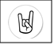

Year 3 information sheet
Lesson 1
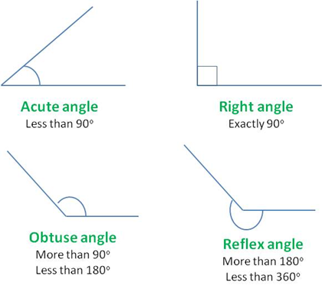

Lesson 2
Right angles
